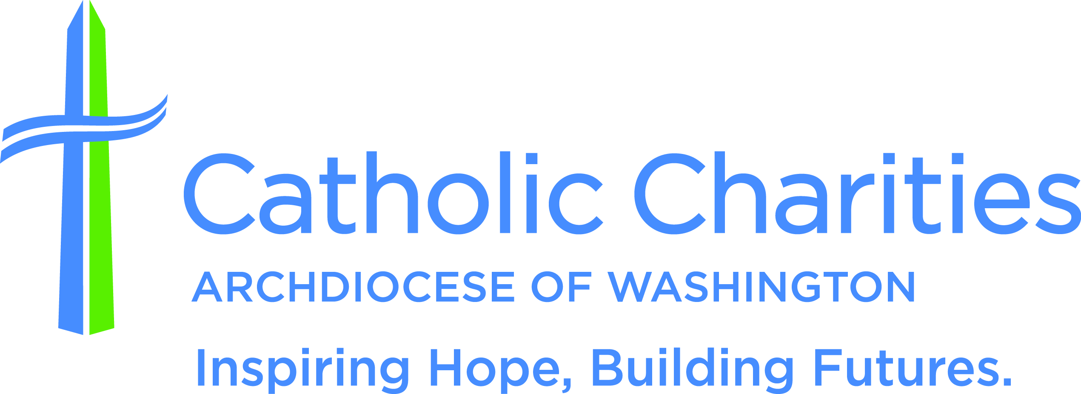

Media Contacts
Addie Kauzlarich Kate Kennedy
Pepco Catholic Charities DC
202-872-2680 (media hotline) 202-772-4312
akauzlarich@pepcoholdings.com Kate.Kennedy@cc-dc.org

Catholic Charities DC and Pepco to Host Annual
Thanksgiving Dinner for People in Need on Nov. 22

Washington, Nov. 17, 2022 — Catholic Charities of the Archdiocese of Washington and Pepco will serve 300 guests who are homeless and hungry a traditional Thanksgiving meal and distribute coats and toiletries on Tuesday, Nov. 22.

The hot meal will be served in a grab-and-go format. Each guest will receive two meals of turkey, mashed potatoes with gravy, collard greens, corn bread and a brownie made by Catholic Charities’ KitchenWork program and served by Catholic Charities staff and volunteers.

After collecting their meals, guests will receive a warm winter coat designed by the homeless for the homeless and a toiletry kit from Pepco staff and volunteers.

The annual meal much anticipated by those experiencing homelessness will be distributed on the sidewalk in front of Pepco Edison Place Gallery.

While homelessness in the District has decreased, thousands remain unhoused. It is estimated that one-third of people in the region have experienced food insecurity in the last year.

In the true spirit of Thanksgiving, this event will provide hearty and nutritious meals and foster a sense of community.

What: Catholic Charities DC and Pepco Community Thanksgiving Dinner

Where: Pepco Edison Place Gallery (outside along the sidewalk in front of the building),
702 8th St. NW, Washington, DC 20068

When: 3:30-5 p.m. on Tuesday, Nov. 22, 2022. Attendees are expected to start lining up early. While they wait in line, they will be given wrapped chocolate bars with a note of thanksgiving.

Who: Msgr. John J. Enzler, president and CEO, Catholic Charities DC, will give a blessing.

Rodney Oddoye, senior vice president of governmental, regulatory and external affairs, Pepco

Holdings, also will be in attendance.

Media: For additional information or to schedule an interview, contact Kate Kennedy of Catholic Charities DC’s Communications department at Kate.Kennedy@cc-dc.org or 202-772-4312, or Addie Kauzlarich of Pepco Communications at akauzlarich@pepcoholdings.com or 202-872-2680.

About Catholic Charities of the Archdiocese of Washington
Catholic Charities DC is the largest independent social services agency in the Metropolitan D.C. area. As the charitable arm of the Archdiocese of Washington, Catholic Charities DC invests in communities by providing critical services to hundreds of thousands of people in need throughout the District of Columbia and Montgomery, Prince George’s, Charles, Calvert and St. Mary’s counties in Maryland. The organization works tirelessly to give help that empowers and hope that lasts to those it serves regardless of background, belief or circumstance. For more information, visit www.catholiccharitiesdc.org and follow us on social media @CCADW.

About Pepco
Pepco is a unit of Exelon (Nasdaq: EXC), a Fortune 200 company and the nation’s largest utility company, serving more than 10 million customers. Pepco provides safe and reliable energy service to approximately 919,000 customers in the District of Columbia and Maryland

