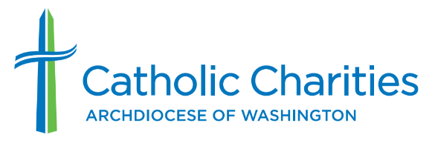

Media Contact
Kate Kennedy
Kate.Kennedy@cc-dc.org
202-772-4312

Catholic Charities to Host Job Fair on Feb. 22
Open positions support school in D.C. and developmental disabilities services

WASHINGTON, Feb. 10, 2023 —Catholic Charities of the Archdiocese of Washington will host a job fair on Feb. 22 for positions supporting its Developmental Disabilities Services and Kennedy School, which provide education and opportunity for hundreds of adults and children each year.
Among current job openings are special education teacher, social worker, teacher assistant, community support specialist, classroom paraprofessional, speech/language pathologist and more.
Applicants are asked to provide a resume and the names of three references. Attendees must be fully vaccinated and wear a mask to the job fair.
What: Catholic Charities Job Fair
When: 10 a.m. to 12 p.m. and 1-3 p.m. on Feb. 22, 2023
Where: Kennedy School at the Catholic Charities Education Center, 801 Buchanan St. NE, Washington, DC 20017
Details: Catholic Charities’ Developmental Disabilities Services provide opportunities for a fulfilling future to individuals with developmental disabilities. In the last year, the department provided help to 283 adults, teens and children.
The Kennedy School works with children and teens with disabilities, offering personalized academic, therapeutic and vocational classes for students ages six to 22.
To learn more about the job fair and register, visit https://bit.ly/3I22biS. Catholic Charities’ career site is available at https://www.catholiccharitiesdc.org/careers/.
Media: For additional information, contact Kate Kennedy of Catholic Charities DC’s communications department at Kate.Kennedy@cc-dc.org or 202-772-4312.
About Catholic Charities of the Archdiocese of Washington
Catholic Charities DC is the largest independent social services agency in the Metropolitan D.C. area. As the charitable arm of the Archdiocese of Washington, Catholic Charities DC invests in communities by providing critical services to hundreds of thousands of people in need throughout the District of Columbia and Montgomery, Prince George’s, Charles, Calvert and St. Mary’s counties in Maryland. The organization works tirelessly to give help that empowers and hope that lasts to those it serves regardless of background, belief or circumstance. For more information, visit www.catholiccharitiesdc.org and follow us on social media @CCADW.

